E1:

Define A’s advantages: . Obviously, is not *negligible*.

E2：

Game as:

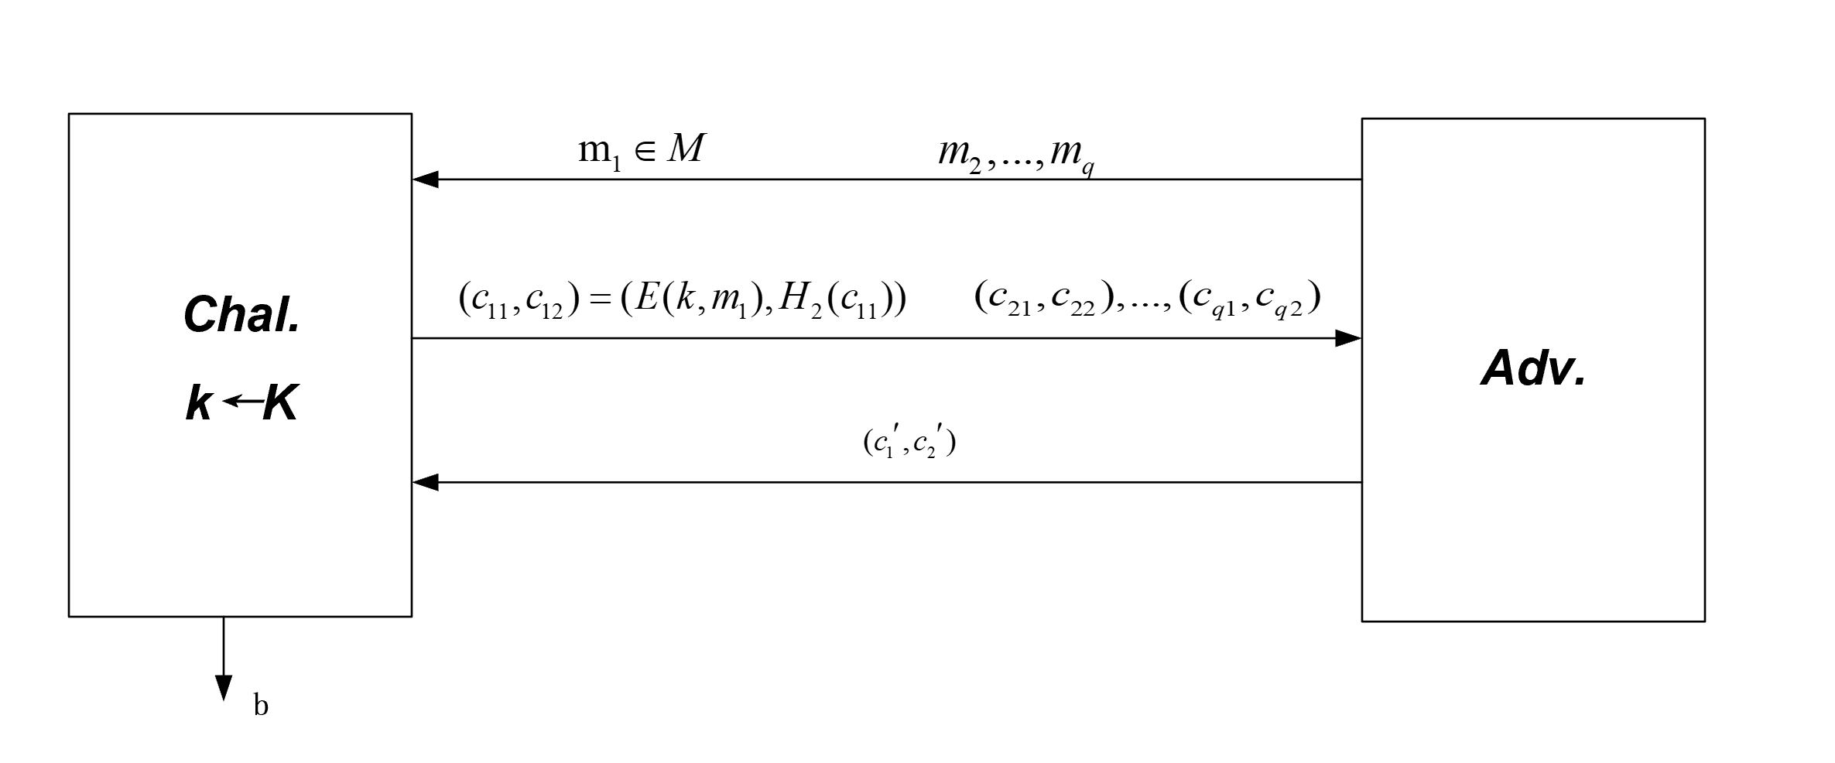

We know that attacker can estimate the value of  from . The is not *negligible*.